Llanddulas Playgroup

February Newsletter

Dear Parents,
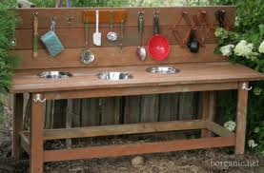
Welcome back after the half-term break, we hope that you had an enjoyable time. This term we will be continuing with our topic of fairytales and nursery rhymes, and keeping with the topic we will be celebrating world book day on Thur 7th March, when your child can come to school dressed as a character from their favourite storybook, remember to send in the book too !!! Please find attached a world book day voucher. (Nursery children will receive their vouchers from the school nursery class shortly as there is only 1 voucher per child) Children can also come to school dressed in Welsh costumes on Fri 1st March to celebrate St David’s day. Now that the weather is getting slightly better, we hope to make more use of our outdoor area, and are hoping to create a mud kitchen similar to this one.

We would be very grateful for donations of old kitchen utensils, pots, pans, cake tins, oven trays etc. If you do have any you no longer require please leave them with a member of staff. Thank-You.

